Demystifying Programming

By Rebecca Kreider (Modified by Mr. K)
This Webquest is designed to demystify programming and introduce you to the world of coding through insightful videos, engaging activities, and additional resources provided to allow for further pursuit of the topic.

Introduction
Welcome to "Demystifying Programming!" The Webquest will take you on an adventure where you will discover why learning to program is important, that programming can be fun, how to program in a few of the hottest languages!
Through a series of videos and online interactions, you will become familiar with computer programming, solve puzzles, make a yeti dance, program Flappy Bird and Plants vs. Zombies, create your own beat, and have the opportunity to explore many additional resources.

Task

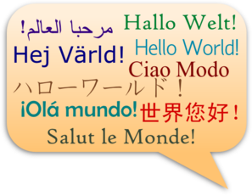
Watch the following video and listen to what people are saying about programming. Learning to program computers, or "code," is an important part of your education. Just like learning to read and write, learning to code will teach you to think logically, organize your ideas, and most importantly participate in the language of today. Coding might be the most important "language" to learn and should be another tool in your toolkit.

The Most Important Language

Now that you have seen the video, answer the following questions in your notebook.

- What will learning to code do for you in the future?
- What other skills will you learn as you learn to code?
- Are you excited to try it?

Now, watch the next video to see more experts discuss how coding has changed their lives and the world we live in.

The World Has Changed

Now that you have seen the video, answer the following questions in your notebook.

- Do you have to be a genius to program?
- Do you have to know everything about computers to program?
- If you were to make a program to anything you wanted, to fix a problem, to automate something, to build a new game, what would it be?
Are you ready to try programming for the first time?

Click Process on the Navigation Menu.

Process
Let's focus on your creative side first. In the following activities you will teach a yeti to dance, create your own beats, and build a cartoon character. You will be using Blockly, a visually-based beginning programming language. Blocks are dragged and snapped into place and the computer executes the commands. This website by Google is designed to increase girls' participation in programming, but it is good for boys, too!
Watch the video Be Inspired and Get Creative!
Be Inspired and Get Creative!
Are you inspired to change the world? Scroll down to PROJECTS and click on MORE PROJECTS. Scroll down to the YETI and click on START DANCING. Follow the instructions. When finished, click DONE and select PROJECTS then complete BEATS and GIF. Be sure to return to the Webquest after you complete the three mini-projects.
Now you have explored making music and animation, let's try to solve some puzzles. Click on the link below to help a robot grow some plants. Talk to your partner before clicking "water" and try to get the puzzles correct on the first try. If you fail, debug the code and make it work.
Made With Code - Robot Botanist
The next challenge is using Blockly code to solve 10 mazes. Click the link below:
Blockly: Mazes
Drag the blocks into the right side of the screen and snap them together to make a program. If needed, drag blocks to the trash can to get rid of them.
When you have successfully completed the 10 mazes, click on TAKE GAME QUIZ and select REVIEW MODE.
Did you pass the quiz? Congratulations! You are on your way to programming.
Do you need inspiration? Watch this kid: Jon Buchanan
Now, let’s program using CODEMONKEY. Click on the link below and complete all 30 levels:
CODEMONKEY: Real Coding
When complete, click on TAKE GAME QUIZ and select REVIEW MODE.
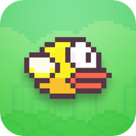
Let's do something kids like to do. Click on the link below and program your own Flappy Bird game. Take turns with your partner programming and playing your game.
Flappy Bird Extreme

Now that you have seen the latest video game programming, let's take a step back in time and look at how programming started. Watch the following video, Binary Numbers, to see how the computer actually processes your commands for Flappy Bird.
Binary Numbers
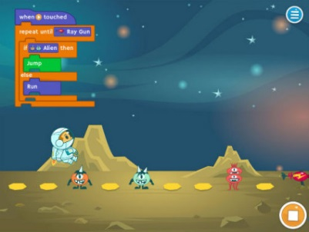
Let's explore Tynker—a visual-based programming language, similar to Blockly. Click on the link below and complete all 30 levels:
Tynker: Lost in Space
You will now use Blockly on code.org's HOUR OF CODE. You will solve more puzzles, help the Angry Bird get the Pig, the Zombie get his Sunflowers, and the Squirrel get his Acorn. Be sure to solve the 20 puzzles with the appropriate amount of blocks!
Based on which period you are in, click on the link below and click on your name. Enter your secret words (get them from Mr. K). Click on HOUR OF CODE and choose what section you want. There are videos on the bottom left side of the screen if you need instructions. Click "Show Code" to see the JavaScript behind the blocks. JavaScript is assembly language where you use letters and numbers instead of blocks. Be sure to return to this Webquest after you complete the HOUR OF CODE.

1st Period: http://studio.code.org/sections/HHFBXJ

4th Period: http://studio.code.org/sections/VPYZSX

6th Period: http://studio.code.org/sections/DMPKDR

Whew! That was easy, right? You are one step closer to demystifying programming. Were you always successful on the first try? Probably not—you had to "debug" or fix your program. Patience and fortitude are important skills. Fortitude is your willingness to stick with it!
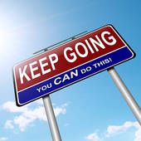

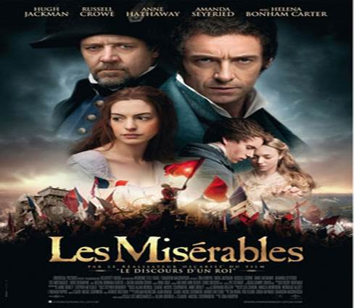
Now that you have done a lot of programming with Blockly, the visual-based language, it is time to take a break and experience a more hearty language. You are going to create a poster! Take your time. If the poster is of high enough quality, you may get to print it ONCE to the color printer in the office.

Make a poster

The following link is to codeacademy.com. Sign up and scroll down and select LEARN JAVA. You should work through the first 20 instructions.
codeacademy.com

Conclusion
Great Job!
You are have completed the requirements for Demystifying Programming!
Now that you have Demystified Programming, I encourage you to explore further with other activities. The following links will allow for more practice, more challenges, and more ways to leave your mark on the world! Get involved!
Explore other languages and application opportunities on codeacademy.com:
codeacademy.com
Return to code.org and pursue the more advanced projects:
code.org
As the videos mentioned, most programmers employed today are young, white men. To encourage more diversity, Black Girls that Code was developed, and Made with Code, a Google-sponsored website aimed at getting girls into programming.
Black Girls that Code
Made with Code Projects
For the most advanced programming opportunities, please visit the following link. This link is to a MOOC, or Massive Open Online Course, from Stanford University. It is free and covers the basics of Computer Science and Programming. Please select the self-paced method.
Computer Science MOOC

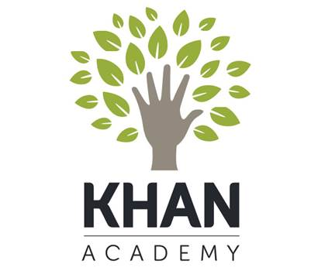
Khan Academy has many hours of coding opportunities. Click on the Hour of Drawing link to experience JavaScript.

Drawing with Javascript
The next link will take you to Khan Academy's HTML activity. HTML is the language to program websites.

Websites - HTML Khan Academy

If you are very interested in programming, try coding in SQL, or Structured Query Language—the language of relational databases! Your resume is blossoming!
SQL and Databases

